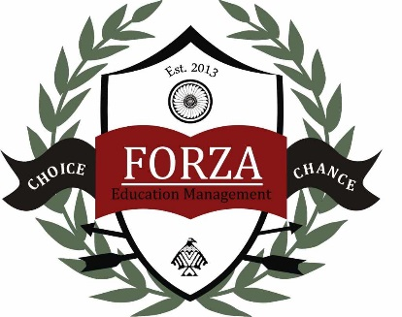
Child Development Center
2019-2020 Pre-K 3 Supply List
- 2 boxes of 8 count large Crayola crayons
- 2 watercolor paints
- 4 packages of glue sticks
- 1 large bottle of Elmer’s glue
- Oversized beginner pencils (made by Ticonderoga)
- Package of dry erase markers
- 2 Packages of construction paper
- Paint smock or old large t-shirt
- 1 ream of white copy paper
- 3 boxes of tissues
- 3 packages of baby wipes
- 1 container of Clorox wipes
- 1 box of gallon sized Ziplock bags
- 1 nap time blanket (no larger than 40”x60”) clearly labeled
with your child’s name on it. (No pillows please)
- 2 full changes of clothing stored in Ziplock bags with your
child’s name clearly labeled on each item.

Please have your child keep any valuable items at home as they might become lost
while at school. This includes all toys, jewelry, fancy hair accessories, etc.
Thank you! ☺

